The Criminal Conspiracy of Coronavirus

Dr. David E. Martin

Throughout the decade of the 90s Pfizer sought to research, develop and patent a coronavirus (CoV) vaccine. Their first patent filing specifically recognizing the S-protein as the immunologic target for vaccines was filed on November 14, 1990 (U.S. Patent 6,372,224). With a focus on swine and canine gastroenteritis, these efforts showed little commercial promise and the patent was abandoned in April of 2000. During the same period, the National Institute for Allergy and Infectious Disease (NIAID) under the vaccine obsession of Dr. Anthony Fauci, funded Professor Ralph Baric at the University of North Carolina Chapel Hill. This program designed to commercially weaponize a naturally occurring toxin is the beginning of the criminal conspiracy and violates 18 USC § 175, 15 USC § 1-3, and 15 USC § 8) Dr. Baric’s expertise was understanding how to modify components of the coronavirus associated with cardiomyopathy. NIAID Grants AI 23946 and GM63228 (leading to patent U.S. 7,279,327 “Methods for Producing Recombinant Coronavirus”) was the NIH’s first Gain-of-Function (GOF) project in which Dr. Baric created an “infectious, replication defective” clone of recombinant coronavirus. This work clearly defined a means of making a natural pathogen more harmful to humans by manipulating the Spike Protein and other receptor targets. A year after filing a patent on this GOF CoV, the world experienced the first outbreak of Severe Acute Respiratory Syndrome (SARS).

Under the guise of responding to a public health emergency, the United States Centers for Disease Control and Prevention (CDC) filed a patent application on the genome of SARS CoV on April 25, 2003. Accessing and manipulating the genomic data (which came from China making an “invention” claim by a U.S. entity illegal violating 35 USC ng 35 USC §101, 103), Dr. Baric, Dr. Fauci, and the CDC violated 18 USC § 175 (a felony). One year earlier, Dr. Baric and his team had already filed a patent which clearly the pathogen CDC claimed as novel in 2003. Three days after filing a patent on the genome, NIH-funded Sequoia Pharmaceuticals filed a patent for the vaccine on the virus invented a mere three days earlier. At the same time, in violation of 15 USC § 19 Dr. Fauci was appointed to a board position with the Bill and Melinda Gates Foundation (a competitor in vaccine manufacturing) thereby beginning the interlocking directorate anti-trust crime.

In 2005, the DARPA and MITRE hosted a conference in which the intentions of the U.S. Department of Defense was explicit. In a presentation focused on “Synthetic Coronaviruses Biohacking: Biological Warfare Enabling Technologies”, Dr. Baric presented the malleability of CoV as a biological warfare agent. Violating 18 USC § 175 and inducing the non-competitive market allocation (violating 15 USC § 8) for years to follow, Dr. Baric and the U.S. Department of Defense spent over $45 million in amplifying the toxicity of CoV and its chimeric derivatives.

From 2011 until the alleged COVID-19 pandemic, Dr. Fauci has routinely lamented about the inadequacy of public funding for his vaccine programs and the public’s general unwillingness to succumb to his insistence that every MUST be vaccinated against influenza. Despite repeated appropriations to advance vaccine dependency, his efforts have been largely unsuccessful. NIAID – under Dr. Fauci’s direct authorization – encouraged UNC Chapel and Dr. Baric’s lab to ignore the GoF moratorium in a letter dated October 21, 2014. At that time, Drs. Fauci, Baric and EcoHealthAlliance’s Peter Daszak were in possession of an extremely dangerous Chinese pathogen identified a year earlier in Wuhan.

While many illegal acts were committed by the conspirators leading up to 2015, the domestic terrorism program (in violation of 18 USC § 2339) was announced by NIAID-funded Daszak at the National Academy of Sciences. Here, he announced what was to become the domestic and global terrorism event branded COVID-19.

“…until an infectious disease crisis is very real, present, and at an emergency threshold, it is often largely ignored. To sustain the funding base beyond the crisis, he said, we need to increase public understanding of the need for MCMs such as a pan-influenza or pan-coronavirus vaccine. A key driver is the media, and the economics follow the hype. We need to use that hype to our advantage to get to the real issues. Investors will respond if they see profit at the end of process, Daszak stated.”

It is not surprising that one year later NIAID’s funding paid off with Dr. Baric’s lab announcing that the Wuhan-derived pathogen was “poised for human emergence”.

Knowing that the U.S. Department of Health and Human Services (through CDC, NIH, NIAID, and their funded laboratories and commercial partners) had patents on each proposed element of medical counter measures and their funding, Dr. Fauci, Dr. Gao (China CDC), and Dr. Elias (Bill and Melinda Gates Foundation) conspired to commit acts of terror on the global population – including the citizens of the United States – when, in September 2019, they published the following mandate in A World At Risk:
“Countries, donors and multilateral institutions must be prepared for the worst. A rapidly spreading pandemic due to a lethal respiratory pathogen (whether naturally emergent or accidentally or deliberately released) poses additional preparedness requirements. Donors and multilateral institutions must ensure adequate investment in developing innovative vaccines and therapeutics, surge manufacturing capacity, broad-spectrum antivirals and appropriate non-pharmaceutical interventions. All countries must develop a system for immediately sharing genome sequences of any new pathogen for public health purposes along with the means to share limited medical countermeasures across countries.
Progress indicator(s) by September 2020
• Donors and countries commit and identify timelines for: financing and development of a universal influenza vaccine, broad spectrum antivirals, and targeted therapeutics. WHO and its Member States develop options for standard procedures and timelines for sharing of sequence data, specimens, and medical countermeasures for pathogens other than influenza.
• Donors, countries and multilateral institutions develop a multi-year plan and approach for strengthening R&D research capacity, in advance of and during an epidemic.
• WHO, the United Nations Children’s Fund, the International Federation of Red Cross and Red Crescent Societies, academic and other partners identify strategies for increasing capacity and integration of social science approaches and researchers across the entire preparedness/response continuum.”

As if to confirm the utility of the September 2019 demand for “financing and development of” vaccine and the fortuitous SARS CoV-2 alleged outbreak in December of 2019, Dr. Fauci began gloating that his fortunes for additional funding were likely changing for the better. In a February 2020 interview in STAT, he was quoted as follows:

“The emergence of the new virus is going to change that figure, likely considerably, Fauci said. “I don’t know how much it’s going to be. But I think it’s going to generate more sustained interest in coronaviruses because it’s very clear that coronaviruses can do really interesting things.”

In November 2019 – one month before the alleged “outbreak” in Wuhan, Moderna entered into a material transfer agreement – brokered by the Vaccine Research Center at NIAID (at which UNC Chapel Hill alum Dr. Kizzy Corbett worked – to access Dr. Baric’s Spike Protein data to commence vaccine development. In his own written statement obtained by the Financial Times, he refers to this agreement as being the foundation for the mRNA Moderna vaccine.

To finalize the nature of the racketeering and anti-trust criminal conspiracy, when it came time to commercialize the NIH and DARPA owned spike protein and pass it off as a “vaccine” (in conflict with the standard for vaccines in statutory and scientific application), the Operation Warp Speed contract was awarded to DoD contraction ATI, a subsidiary of ANSER. In a graph reminiscent of the anti-trust hearings at the formation of the Clayton Act in the early 20th century, the identify of the interlocking conflicts of interests are presented in graphic relief. It is with no surprise that the result of this price-fixing conspiracy was the enrichment of the conspiring parties and the harm of consumers.

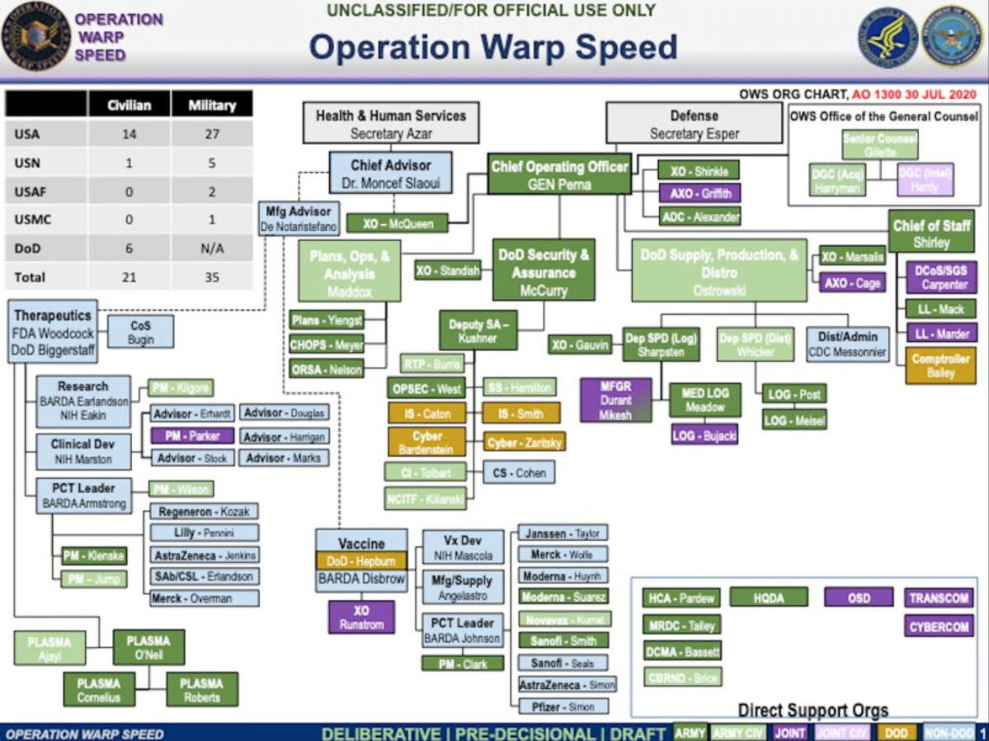

Indeed, the money followed the hype and they used the hype to get to the real issues. Investors follow where they see profit at the end of the process.

And real Americans are dying each day because a criminal organization unleashed terror resulting in the deaths of Americans.

18 U.S.C. § 2331 §§ 802 – Acts of Domestic Terrorism resulting in death of American Citizens

Pub. L. No. 107-52 expanded the definition of terrorism to cover "domestic," as opposed to international, terrorism. A person engages in domestic terrorism if they do an act "dangerous to human life" that is a violation of the criminal laws of a state or the United States, if the act appears to be intended to: (i) intimidate or coerce a civilian population; (ii) influence the policy of a government by intimidation or coercion;

Every single Act, the declaration of the State of Emergency, the Emergency Use Authorization, the fraudulent face masks, the business closures, and the OSHA and CMS vaccine mandates are ALL admitted by the conspirators to be acts to coerce the population into taking a vaccine. They announced it in 2015, the prepared the pathogen in 2016, and laid out the terror campaign in September 2019. And now they profit from the death of Americans.

We note that gain-of-function specialist, Dr. Ralph Baric, was both the recipient of millions of dollars of U.S. research grants from several federal agencies and sat on the World Health Organization’s International Committee on Taxonomy of Viruses (ICTV) and the Coronaviridae Study Group (CSG). In this capacity, he was both responsible for determining “novelty” of clades of virus species but directly benefitted from determining declarations of novelty in the form of new research funding authorizations and associated patenting and commercial collaboration. Together with CDC, NIAID, WHO, academic and commercial parties (including Johnson & Johnson; Sanofi and their several coronavirus patent-holding biotech companies; Moderna; Pfizer; Merck; BioNTech; AstraZeneca; Janssen; Ridgeback; Gilead (Dr. Baric’s alter ego); Sherlock Biosciences; and others), a powerful group of interests constituted what are “interlocking directorates” under U.S. anti-trust laws. Further, most of these entities, including the Federal Government ones violated 35 USC § 200-206 by failing to disclose Federal Government interest in the remedies proposed. These entities were affiliated with the WHO’s Global Preparedness Monitoring Board (GPMB) whose members were instrumental in the Open Philanthropy-funded global coronavirus pandemic “desk-top” exercise EVENT 201 in October 2019. This event, funded by the principal investor in Sherlock Biosciences (a beneficiary of the SARS CoV-2 EUA for CRISPR technology) and linking interlocking funding partner, the Bill and Melinda Gates Foundation into the GPMB mandated a respiratory disease global preparedness exercise to be completed by September 2020 and alerted us to anticipate an “epidemic” scenario. We expected to see such a scenario emerge from Wuhan or Guangdong China, northern Italy, Seattle, New York or a combination thereof, as Dr. Zhengli Shi and Dr. Baric’s work on zoonotic transmission of coronavirus identified overlapping mutations in coronavirus in bat populations located in these areas.
By October 2013, the Wuhan Institute of Virology 1 coronavirus S1 spike protein was described in NIAID’s funded work in China. This work involved NIAID, USAID, and Peter Daszak, the head of EcoHealth Alliance. This work, funded under R01AI079231, was pivotal in isolating and manipulating viral fragments selected from sites across China which contained high risk for severe human response. (Ge, XY., Li, JL., Yang, XL. et al. Isolation and characterization of a bat SARS-like coronavirus that uses the ACE2 receptor. Nature 503, 535–538 (2013).) The GoF work NIAID allowed to persist in the face of the moratorium was Dr. Baric’s work with this pathogen
Forum on Medical and Public Health Preparedness for Catastrophic Events; Forum on Drug Discovery, Development, and Translation; Forum on Microbial Threats; Board on Health Sciences Policy; Board on Global Health; Institute of Medicine; National Academies of Sciences, Engineering, and Medicine. Rapid Medical Countermeasure Response to Infectious Diseases: Enabling Sustainable Capabilities Through Ongoing Public- and Private-Sector Partnerships: Workshop Summary. Washington (DC): National Academies Press (US); 2016 Feb 12. 6, Developing MCMs for Coronaviruses. Available from: https://www.ncbi.nlm.nih.gov/books/NBK349040/
Menachery VD, Yount BL Jr, Sims AC, Debbink K, Agnihothram SS, Gralinski LE, Graham RL, Scobey T, Plante JA, Royal SR, Swanstrom J, Sheahan TP, Pickles RJ, Corti D, Randell SH, Lanzavecchia A, Marasco WA, Baric RS. 2016. SARS-like WIV1-CoV poised for human emergence. Proc Natl Acad Sci U S A. 2016 Mar 14. pii: 201517719
https://apps.who.int/gpmb/assets/annual_report/GPMB_annualreport_2019.pdf (page 8)
https://www.statnews.com/2020/02/10/fluctuating-funding-and-flagging-interest-hurt-coronavirus-research/
https://pubmed.ncbi.nlm.nih.gov/32756549/

