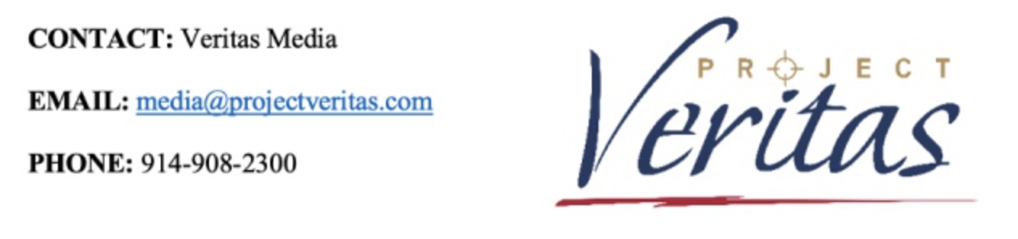
FBI and Southern District of New York Raid Project Veritas Journalists’ Homes

A message from Project Veritas founder and CEO, James O’Keefe.

I awoke to the news that apartments and homes of Project Veritas journalists, or former journalists, had been raided by FBI agents. It appears the Southern District of New York now has journalists in their sights for the supposed “crime” of doing their jobs lawfully and honestly. Or at least, this journalist.

I had to think long and hard before making this statement. It’s a decision that only I can make. They don’t want me to defend myself and immediately tried to silence me. That’s why the cover letter for the Grand Jury Subpoena we received contains this language:

The Government hereby requests that you voluntarily refrain from disclosing the existence of the subpoena to any third party. While you are under no obligation to comply with our request, we are requesting you not to make any disclosure in order to preserve the confidentiality of the investigation and because disclosure of the existence of this investigation might interfere with and impede the investigation.

But while the Department of Justice requested us to not disclose the existence of the subpoena, something very unusual happened. Within an hour of one of our reporters’ homes being secretly raided by the FBI, The New York Times, who we are currently suing for defamation, contacted the Project Veritas reporter for comment. We do not know how The New York Times was aware of the execution of a search warrant at our reporter’s home, or the subject matter of the search warrant, as a Grand Jury investigation is secret.

The FBI took materials of current, and former, Veritas journalists despite the fact that our legal team previously contacted the Department of Justice and voluntarily conveyed unassailable facts that demonstrate Project Veritas’ lack of involvement in criminal activity and/or criminal intent. Like any reporter, we regularly deal with the receipt of source information and take steps to verify its authenticity, legality, and newsworthiness. Our efforts were the stuff of responsible, ethical, journalism and we are in no doubt that Project Veritas acted properly at each and every step.

However, it appears journalism itself may now be on trial.

Late last year, we were approached by tipsters claiming they had a copy of Ashley Biden’s diary. We had never met or heard of the tipsters. The tipsters indicated that the diary had been abandoned in a room in which Ms. Biden stayed at the time, and in which the tipsters stayed in temporarily after Ms. Biden departed the room. The tipsters indicated that the diary included explosive allegations against then-candidate, Joe Biden. The tipsters indicated that they were negotiating with a different media outlet for the payment of monies for the diary. The tipsters were represented by attorneys who handled the negotiations with Project Veritas.

We investigated the claims provided to us, as journalists do. We took steps to corroborate the authenticity of the diary. At the end of the day, we made the ethical decision that because, in part, we could not determine if the diary was real, if the diary in fact belonged to Ashley Biden, or if the contents of the diary occurred, we could not publish the diary and any part thereof. We attempted to return the diary to an attorney representing Ms. Biden, but that attorney refused to authenticate it. Project Veritas gave the diary to law enforcement to ensure it could be returned to its rightful owner. We never published it.

Now, Ms. Biden’s Father’s Department of Justice, specifically the United States Attorney’s Office for the Southern District of New York, appears to be investigating the situation, claiming the diary was stolen. We don’t know if it was, but it begs the question: in what world is the alleged theft of a diary investigated by the President’s FBI and his Department of Justice? A diary! This federal investigation smacks of politics. Project Veritas never threatened or engaged in any illegal conduct.

Should the Southern District of New York try to take away our First Amendment rights to uncover and publish newsworthy stories without government intimidation, be assured, Project Veritas will not back down.

Nothing stops at Project Veritas.

Let me be clear. Our mission is to serve the public’s right to know by illuminating, revealing and exposing information others wish to hide for the wrong reasons. To quote Lord Acton, we believe everything kept secret degenerates. We don’t mislead or conceal. We investigate facts and potential newsworthy information. Sometimes, as was the case here, after we investigate, we decide to not publish a news story. Project Veritas will run from nothing, and we will hide from nothing. We exist for the very purpose of discovering and revealing the truth, in hope to make the world a more transparent place.

Now, this is not the first time we have been attacked and it will not be the last. We know why. We’ve investigated powerful people, and, in many ways, we are the tip of the spear, but we never break the law. Our rule is to act as if there are 12 jurors on our shoulders all the time. The truth will vindicate us.

When the FBI and the Southern District of New York seize reporter’s notebooks, it is not just an attack on Project Veritas. It is an attack on every American and our sacred right to free speech and a free press. The First Amendment is first for a reason: it guarantees all the other rights that follow, because it’s about accountability. Without accountability, freedom itself is an illusion.

So, the great question is: Is this an indicator in the direction that America is going?

We’ve gone far beyond the point of partisan politics in this country. They ask us to focus on our divisions. They don’t ask us to focus on the things which unite us. What unites us is so much more powerful than what divides us.

The First Amendment doesn’t just matter to people on one side. It matters to people on all sides.

That is why I’m calling on all Americans, and especially all journalists, to stand with us for the right to free speech, the free press, and to send a message that the politics of fear will not prevail in the United States of America.
About Project Veritas
James O'Keefe established Project Veritas in 2010 as a non-profit journalism enterprise to continue his undercover reporting work. Today, Project Veritas investigates and exposes corruption, dishonesty, self-dealing, waste, fraud, and other misconduct in both public and private institutions to achieve a more ethical and transparent society and to engage in litigation to: protect, defend and expand human and civil rights secured by law, specifically First Amendment rights including promoting the free exchange of ideas in a digital world; combat and defeat censorship of any ideology; promote truthful reporting; and defend freedom of speech and association issues including the right to anonymity. O'Keefe serves as the CEO and Chairman of the Board so that he can continue to lead and teach his fellow journalists, as well as protect and nurture the Project Veritas culture.
Project Veritas is a registered 501(c)3 organization. Project Veritas does not advocate specific resolutions to the issues raised through its investigations.
Subscribe to Project Veritas on YouTube: https://www.youtube.com/c/veritasvisuals
Follow James O’Keefe on Instagram: https://www.instagram.com/jamesokeefeiii/
Follow Project Veritas on Instagram: https://www.instagram.com/project_veritas/
Follow James O’Keefe on Telegram: https://t.me/JamesOKeefeIII
Follow Project Veritas on Telegram: https://t.me/project_veritas

