Fluoride Links. The detrimental impact of Fluoride on Health and IQ.
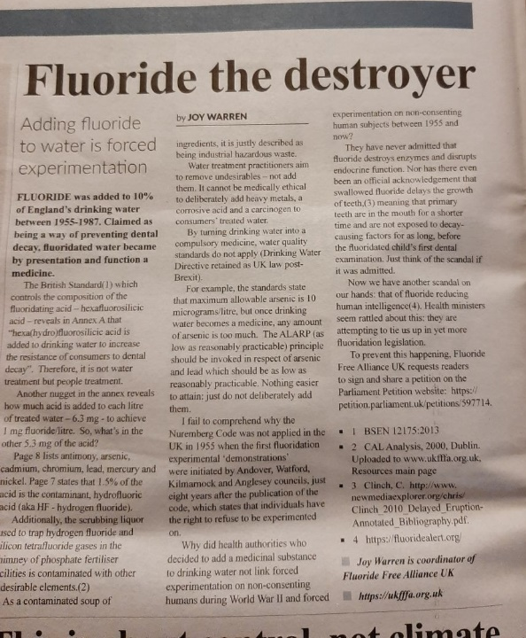
- Fluoride in Our Water | 2 Alarming New Studies https://youtu.be/2nizvddHUd0, Fluoride has been incorporated into our community drinking water since the 1940's.
- They have known for a very long time that Fluoride is poisonous: http://therabbithole.wiki/fluorine-intoxication-by-kaj-roholm-1937/
- In Tea. https://www.robertbarrington.net/fluoride-in-tea-2/; https://www.researchgate.net/figure/Tea-brands-weight-of-teabag-and-fluoride-content-in-tea-infusions_tbl1_317789053
- Legal case update. https://youtu.be/uMpj5uA_BEI
- Interviews with leading scientists on why water fluoridation is madness. https://m.youtube.com/watch?v=88pfVo3bZLY
- The Evil of Fluoridation https://www.youtube.com/watch?v=NLnvgMGvo3k
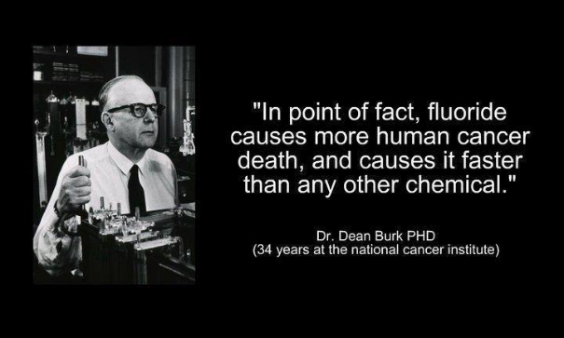
- Fluoride lowers IQ according to Harvard study, which is widely used in tooth paste and drinking water https://www.vaken.se/fluoride-lowers-iq-according-to-harvard-study/.
- What's Really Going On? Dr. Dietrich Klinghardt https://youtu.be/JyyAUx6fkOU Klinghardt describes here the relationship between the pineal gland, W-LAN, 5G and toxins such as glyphosate and aluminium. What does all this have to do with transhumanism?
- Prescription Drugs That Contain Fluoride (Search 325+ Drugs); https://truthaboutfluoride.com/drugs-that-contain-fluoride.
- Fluoride and Cancer. https://twitter.com/thehealthb0t/status/1472514877583470604?t=JFQLXejSUHw359QHRHxszg&s=09; https://t.co/yZGp0e04Sz
- Fluoride Free Alliance leaflet.
- Lord Reay, a hereditary peer, in the House of Lords: “Note the study which showed a massive 9 point decline in IQ in infants who were bottle-fed in areas with fluoridated water. The goal of this measure is clearly to achieve a major decline in IQ in future generations, making them yet more docile and incapable of understanding what is being done to them. Currently around six million people receive this form of soma in the UK but the new 'Health and Care' (Sickness and Abuse) Bill would give the Health Secretary dictatorial power to order water fluoridation across the country. We are monitoring the situation and will get a fluoride removal attachment to our water filter if this truly Huxleyan measure is introduced. There will be a public consultation once the bill becomes law next year so we need get as many people as possible to write to oppose this.” https://www.bitchute.com/video/3pzCEFACR88y/ Transcript: https://hansard.parliament.uk/Lords/2021-12-07/debates/0881f9f2-e818-4ba1-a02d-04d05e8bc17d/LordsChamber
- Interview with Joy Warren https://awakeningnation.com/fluoride-in-water-is-hazardous-waste-govt-want-to-fluoridate-whole-of-uk/

